Support Document

for

Lab Surveillance System

**Prepared by Hinel Mistry**

**C S Patel Institute Of Technology, Changa**

**30 January, 2020**

**Table of Contents**

Table of Contents ii

1. Introduction 1

1.1 Purpose 1

1.2 Document Conventions 1

1.3 Intended Audience and Reading Suggestions 1

1.4 Project Scope 1

2. Overall Description 2

2.1 Product Perspective………………………………………………………………………………...2

2.2 Product Features 2

2.3 Operating Environment 2

2.4 Design and Implementation Constraints 3

2.5 Additional Information 3

# Introduction

The word Surveillance means to monitor the activities of an individual or a group or to observe a specific area.

This section gives a scope description and overview of everything included in this SRS document.

## Purpose

The purpose of this document is to give a detailed description of the requirements for the “**Lab Surveillance System**” software. It will illustrate the purpose and complete declaration for the development of system. It will also explain system constraints, interface and interactions with other external applications. This document is primarily intended to be proposed to a customer for its approval and a reference for developing the first version of the system for the development team.

## Document Conventions

|  |  |  |
| --- | --- | --- |
|  | FONT STYLE | FONT SIZE |
| Title of chapters | Times New Roman | 16 BOLD |
| Sub-title of each chapters | Times New Roman | 12 BOLD |
| Description of each chapter | Times New Roman | 12 |

## Intended Audience and Reading Suggestions

This Software Requirements document is intended for:

* Developers who can review project’s capabilities and more easily understand where their efforts should be targeted to improve or add more features to it (design and code the application – it sets the guidelines for future development).
* Project testers can use this document as a base for their testing strategy as some bugs are easier to find using a requirements document. This way testing becomes more methodically organized.
* End users of this application who wish to read about what this project can do.

## Project Scope

This Application is developed for Head of Department. The purpose of this application is to provide the video stream of computer lab to be accessed remotely and also to control certain aspects of the lab through an announcement system.

# Overall Description

## Product Perspective

This System is being built for Surveillance of the computer labs of the university for monitoring the students who are accessing the labs after college hours and on week days. The streaming service is provided through an android app. It would be provided to our Head of Department. We have also provided the feature to make announcement with the help of an android app.

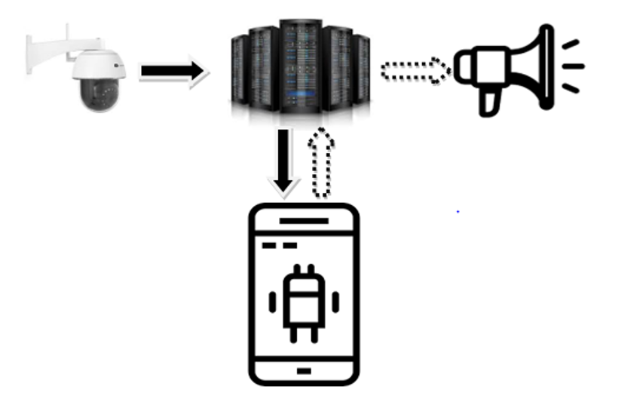

## Product Features

* Live Streaming
* Announcement System
* Setting Dynamic IP

## Operating Environment

Operating environment for the Lab Surveillance System is as listed below.

* OS: Windows
* Platform: Android
* Additional Languages Used: Python, Java
* Technologies: OpenCV, Socket Programming, RTSP (Real Time Streaming Protocol).

## Design and Implementation Constraints

* They should have server
* They should have one Public IP Address
* Sufficient IP Camera and speaker
* Android phone is necessary

## Additional Information

* **Ip Camera:** This required for Capturing the video. 5MP 720p Video stream.
* **OpenCV:** It will be used for image processing
* **RTSP (Real Time Streaming Protocol):** This protocol helps in transferring video stream.
* **Speaker:** This is used for announcements.